Coordinated Assistance Ministries, Inc.

Take a look at what clients have to say about C.A.M.

We look forward to partnering with you to move C.A.M. into its

next phase of ministry as we continue to serve the community.

TO DONATE:

Send your gift to

P.O. Box 523

Kokomo, IN 46903

or give via PayPal at www.camhope.org

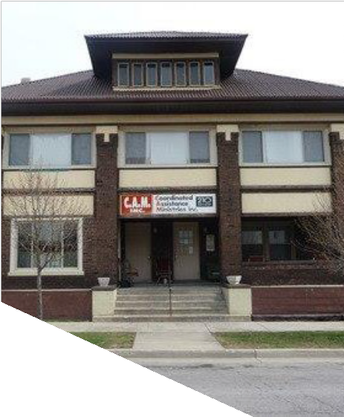

“BELIEVE!” CAPITAL CAMPAIGN

**…All things are possible for one who believes.”**

**Mark 9:23b**

* Imagine being at your lowest point in

life and feeling that you’re just stuck. That’s exactly how I felt. I was already determined and strong minded, but I just needed that “push” which is what C.A.M. has given me. They have given me on- going support for work, housing, and resources that just keep opening more doors for me.…I am now a graduate of Ivy Tech community college pursuing more education in my field. With the help of one of the administrators at C.A.M., I landed an awesome job, and most importantly, I now have my own place

for my family. 

**S. Alexander**

**C.A.M. Client**

This program gives you an opportunity to

get on your feet. There is help here in

Kokomo for people, if you ask! 

**Patricia M.**

**C.A.M. Client**

If it was not for the C.A.M. center, I wouldn't have

any furniture in my house. They helped me a lot and

they did a good job. All you have to do is call them

and they will help you! 

**Stacy S.**

**C.A.M. Client**

Dennine Smith, MPH

Executive Director

(765)434-0687

www.camhope.org

P.O. Box 523,

Kokomo, IN 46903

# 

# What’s next for C.A.M.?

C.A.M. has been in its current building located at 210 North Market Street for over 26 years, but with the addition of services and programs through the years, the ministry has outgrown this building.

In order to meet our need for additional space, it is critical that we relocate.

We are purchasing a facility located on Union Street. This one-story building offers the shelter, office, meeting, and storage space that C.A.M. needs to continue to grow the ministry and expand its services.

FUTURE HOME OF

COORDINATED ASSISTANCE MINISTRIES

625 N. Union Street

Kokomo, IN 46901

# Who is

Coordinated Assistance Ministries, Inc.?

**Coordinated Assistance Ministries, Inc. has served the community for over 28 years.** Our mission is “to show God's love by meeting unmet needs and to empower individuals and families in our community.”

We **operate a men's shelter, a family shelter, and a day shelter (or drop-in center) for the homeless.**

**Services**

* Every day, clothing, coffee, donuts, bread, pizza and other perishable and non-perishable food items are available at C.A.M.!

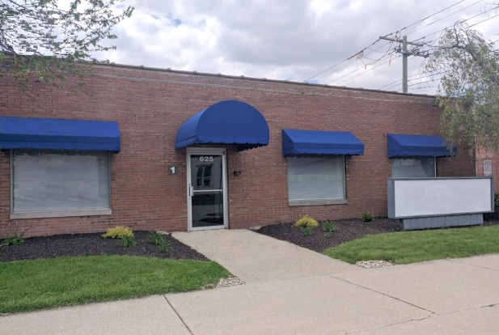

* C.A.M. helps to prevent homelessness by assisting with **budgeting** and **helping individuals pay their monthly expenses.**
* **Furniture and appliances** donated to C.A.M. are **given** to families and individuals with low income.
* **Hygiene kits** are available once per month to individuals in need.
* **And** most importantly, staff and volunteers build relationships with those we serve.

# What will it cost?

# Building $220,000

# Building Modifications $100,000

# Security System & Appliances $30,000

# **Total $350,000**

# How will we do this?

In order for us to meet this ministry need it is necessary for us to engage in a capital campaign, so we introduce…

The “Believe!” Capital Campaign”

* We are seeking out individuals, churches, community organizations, businesses and others to partner with us over a two-year period to help us purchase this facility and make the necessary modifications. Our fundraising goal for this capital campaign is **$100,000.**
* We are pursuing funding from other sources to cover the remaining costs of this project.

How can you help?

1. **Make a pledge!** Make a one-time donation or select an amount to give over a two-year period towards this project.
2. **Call (765)434-0687 to learn more about this project or** to schedule a presentation for your group.